Performance Tests:
Red-Black Tree
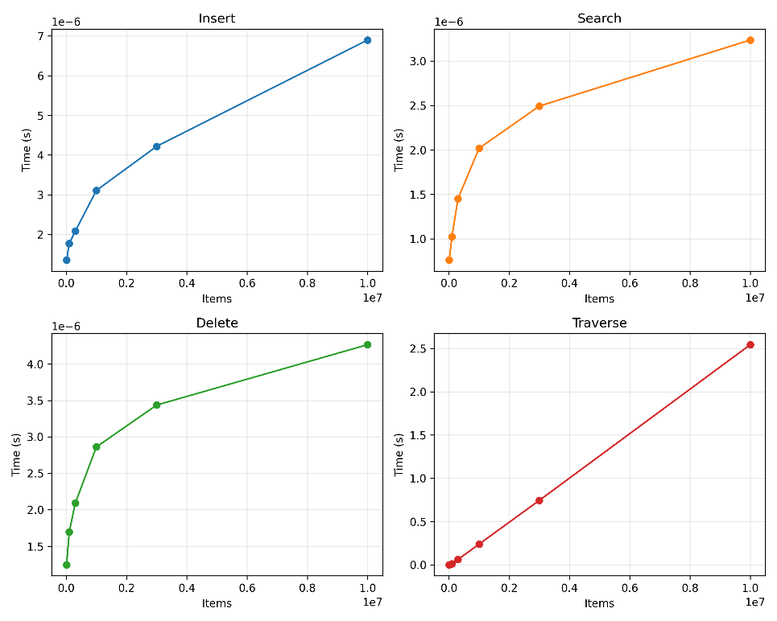
The points for insertion and deletion show that average time per insertion / deletion from input sizes ranging from 10,000 to 10,000,000. Search times show the average time for a search at each given input size. To measure each element in the tree was searched for and the time was averaged out. The traversal time shows the time taken for a single traversal at each input size. The whole range of sizes tested was, [10000, 100000, 300000, 1000000, 3000000, 10000000] with each input size run twice and averaged get a final value for each measurement.

Standard Binary Search Tree
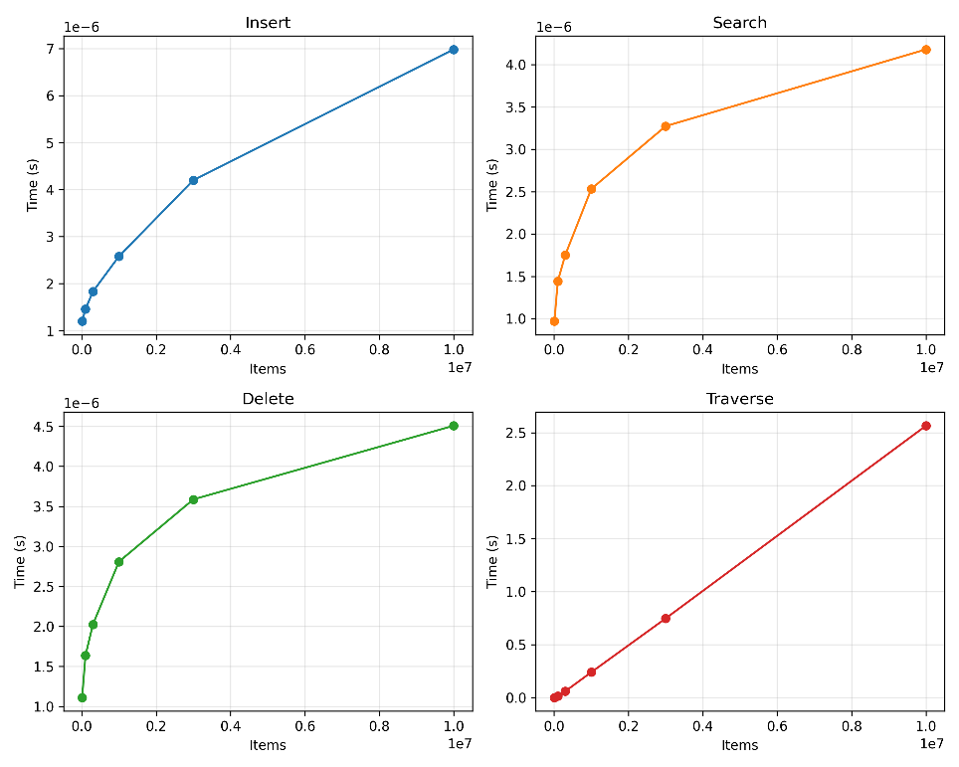
The standard binary tree had nearly identical insert times at larger input sizes, however, at smaller sizes it was actually faster. This is probably because of the extra overhead from checking and editing the tree every time an element is inserted. Deletion was slightly faster in the Red-Black tree, likely because of the speed improvements to search which was used to find the element that was being deleted. Search had the largest speed increase in the Red-Black tree, this is because it ensures that the tree does not become unbalanced and result in more nodes being searched. Traversal was identical in both trees as the same algorithm was used in both and tree proportionality does not have any large effect in its efficiency.
Both trees show a log(n) time complexity for insertion, deletion, and searching with an n time complexity for traversal which matches what a Red-Black and standard binary tree are supposed to be.

Design choices:
I decided to use python because I have been using it for much longer than any other language. I considered using c because I knew python would be slow, however, I decided I didn’t want to have to deal with keeping track of what’s a pointer vs a piece of data and c can be a little more tricky to debug than python which turned out to be more important that I initially thought.
Both the tree and each node was implemented as a class with nodes holding values for its value, color, parent, left branch, and right branch. None was used as NIL just because that’s what I figured would be the easiest initially, however, this lead to some extra if statements to ensure I wasn’t trying to read a value from None.
I went a little heavier on the type hints than usual because it meant vs code tracked what type every variable was really nicely which prevented some working backwards if I ended up with some spaghetti code. I also added an __repr__ function to the Node class because I used print to debug everything and being able to see the value and color of the node by using print(example_node) is easier than having to do multiple print statements. I also had the __repr__ functions draw out my tree when I was just starting by adding a print statement in the function, which then called the __repr__ function for the node that was supposed to be printed.
The Tree class held public functions for insert, delete, search, and traverse with multiple private functions to help prevent code from getting too long or repeated too often. The private functions is really more of a convention than anything and helps with vs code a bit, however adding an underscore before a function name doesn’t do anything functionally. All that the tree class stored was a root node.
To start I implemented some of the helper functions from the slideshow such as the sibling _locate_parent functions.
To insert values into the tree, a new node with the given value is made, then the _locate_parent function finds the parent of the new node. The function check to see if the new node is the root node and stop if it is. It then adds the node into the spot as if it was a standard binary tree. The insert fix takes care of adjusting the standard binary search tree into a Red-Black tree.
The _insert_fix function runs a loop while node being checked is not the root and its parents color is red. In the loop the function takes care of checking special cases like the node not having a grandparent, or uncle. The function starts by taking care of the color of the nodes on the tree and transitions to checking for cases where a left or right rotate is needed.
The _left_rotate and _right_rotate rotate the tree by constructing replacing the parent references of the affected nodes and transferring the inside branch of the side being rotated up to the inside branch of the node being rotated down.
The delete function starts by searching for a node with the given value. It then does a standard binary tree deletion by replacing it with the greatest value in the left branch with the left child of the greatest node being moved to the right child of its parent. The function stores a removed_color variable that stores the color of the node that is being deleted. Then if the removed node is black, _delete_fix is called.
_delete_fix implements a fix for four cases. If the sibling of the removed node is red, it rotates the parent node left and colors the sibling to be black. The if the sibling is black with two children, the sibling gets recolored to red and the checked node moves to its parent. If the sibling is black with one red child and one black child (inside-red, outside-black) rotate the sibling right and recolor is so the the red child moves up. If the sibling is black with a red outside child rotate the parent node left, recolor the sibling to the parents old color, and color the parent and left child black.
The _delete_fix definitely took the longest to figure out and caused me to stare at a whiteboard for way too long. However, there were some websites like geeks for geeks that were very helpful.
The search function was relatively easy to implement and run a loop to move down the tree until the node is found or doesn’t exist.
The traverse function called a recursive function within itself to walk up the tree and make sure everything was returned in the correct order.

Test Suite:
The test suite includes an _validate method to check all of the rules of a red-black tree that were outlined in the pdf, along with the theorms that were stated. It also includes basic tests for several cases with insertion, and deletion. Along with tests for traversal and searching. Finally it has a stress test to simulate random operations being run on the tree.
The test script also includes the code for the performance tests which inserts n elements, searches for each element, traverses the tree, then deletes each element. The values for inserting, searching, and deleting are averaged out to get a time per operation. The test data is displayed using matplotlib so that its easy to see the time complexity for each operation.
The binary search tree used as a reference was just copied and pasted from the red black tree and had the restructuring and coloring elements removed from it. Everything else about it is the same.

